**Monitoring Task**

**Task Description:**

Install Prometheus and Grafana on a Linux EC2 machine, connect Prometheus to Grafana, and create a dashboard to view metrics.

**Techstacks need to be used:**

* AWS EC2
* Prometheus
* Grafana
* Node Exporter

**Step 1: Launch EC2 Instance:**

* Go to AWS Management Console -> EC2 -> Launch Instance
* Choose Amazon Linux 2023
* Instance Type: t2.micro (free tier)
* Security Groups:
  + Inbound Rules:
    - SSH: Port 22
    - Prometheus: Port 9090
    - Grafana: Port 3000
    - Node Exporter (Port 9100)
* Launch and connect to the instance

**Step 2: Update System and Install Dependencies**

**~** sudo yum update -y

~ sudo yum install wget curl nano -y # Amazon Linux

**Step 3: Install Prometheus**

* wget <https://github.com/prometheus/prometheus/releases/download/v3.2.1/prometheus-3.2.1.linux-amd64.tar.gz>
* tar xvf prometheus-*.linux-amd64.tar.gz
* cd prometheus-*.linux-amd64
* sudo mv prometheus /usr/local/bin/
* sudo mv promtool /usr/local/bin/
* sudo mkdir /etc/prometheus /var/lib/prometheus
* sudo mv prometheus.yml /etc/prometheus/

**Step 3.1: Create Prometheus Service**

sudo nano /etc/systemd/system/prometheus.service

Add the following content

**Step 3.2: Enable and Start Prometheus**

* sudo systemctl daemon-reload
* sudo systemctl enable prometheus
* sudo systemctl start prometheus
* sudo systemctl status Prometheus

**Step 3.3: Now Access Prometheus in browser**

Open http:// 54.196.212.8:9090

**Step 4.1: Install Grafana**

* sudo yum install https://dl.grafana.com/oss/release/grafana-10.4.0-1.x86_64.rpm
* sudo systemctl start grafana-server
* sudo systemctl enable grafana-server
* sudo systemctl status Grafana-server

**Step 4.2: Now Access Grafana in browser**

Open http:// 54.196.212.8:3000

Default credentials: admin/admin

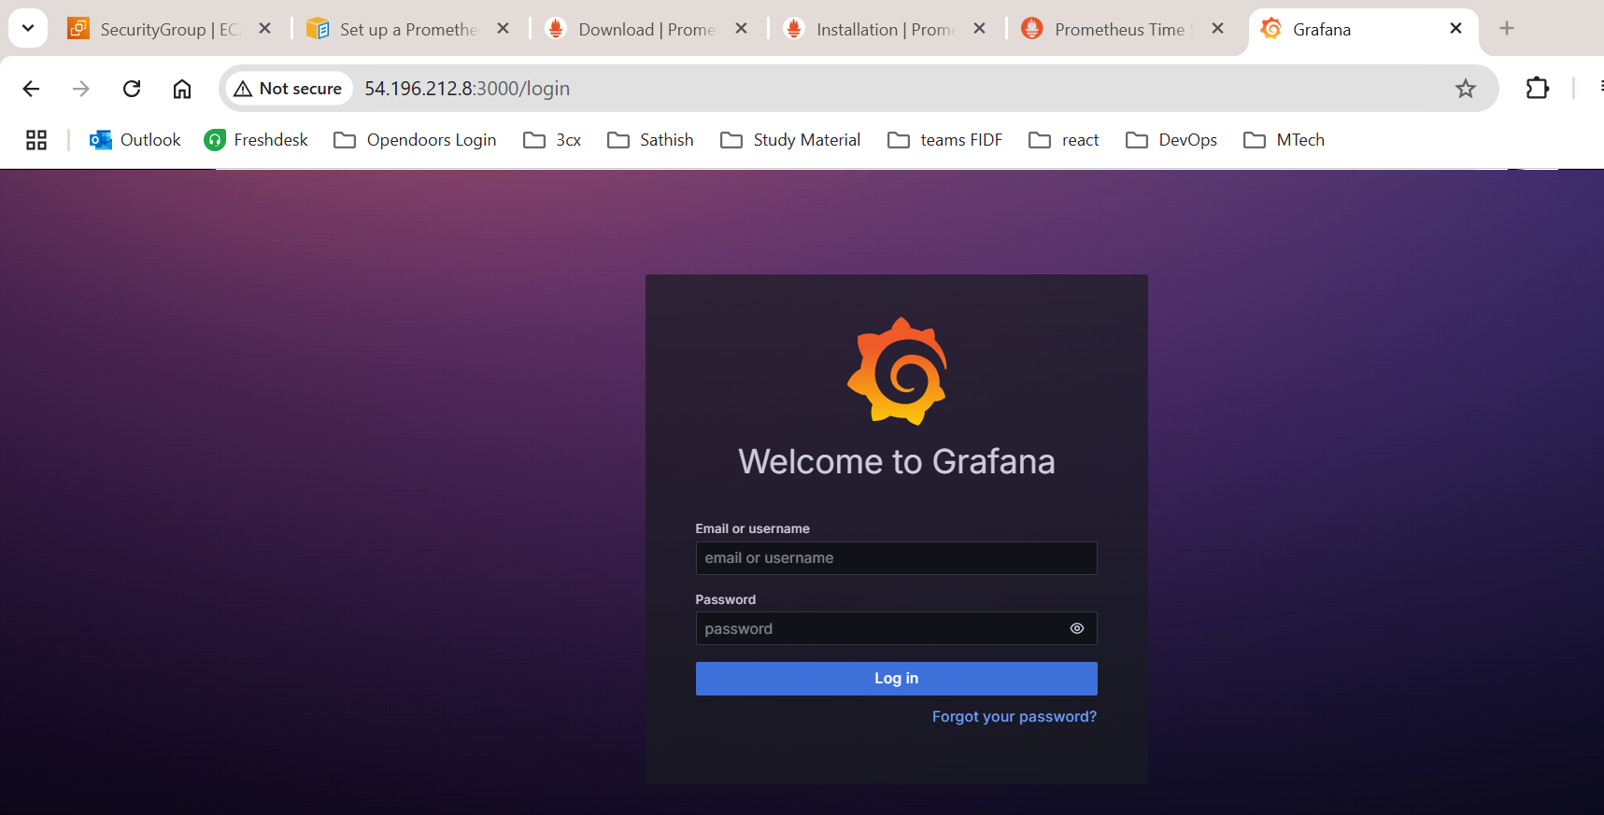

**Step 5: Configure Grafana**

**5.1 Add Prometheus as Data Source:**

* In Grafana → Connections → Data Sources → Add Data Source.
* Choose Prometheus and set the URL to <http://localhost:9090>

5.2 **Create Dashboard:**

* Import Node Exporter dashboard by using ID 1860 from Grafana’s public dashboards

**Step 6.1: Install Node Exporter**:

* wget -qO- https://api.github.com/repos/prometheus/node_exporter/releases/latest | grep "browser_download_url.*linux-amd64.tar.gz" | cut -d '"' -f 4
* tar xvf node_exporter-*.linux-amd64.tar.gz
* cd node_exporter-*.linux-amd64
* sudo mv node_exporter /usr/local/bin/

**6.2: Create Node Exporter Service:**

sudo nano /etc/systemd/system/node_exporter.service

**6.3: Enable and Start Node Exporter**

* sudo systemctl daemon-reload
* sudo systemctl enable node_exporter
* sudo systemctl start node_exporter
* sudo systemctl status node_exporter

**Step 7: Metrices of Grafana – Node Exporter**

